Annual visit: 17 November 2012, Penn Church
The Society’s annual visit took place this year on Saturday 17 November when we visited Holy Trinity Church at Penn along with others attending this open event.
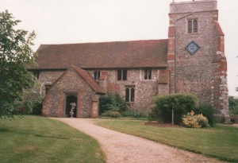
Holy Trinity Church, Penn
© Copyright Gary Davies and licensed for reuse
It consisted of a fascinating talk by Miles Green, honorary archivist and historian of this 12th-century grade I Listed church.
As he pointed out, while it was established in the 12th Century the current building reflects not only architectural changes, but, together with its associated documents, the dramatic changes in social, political and religious history since its establishment. Each century had added or removed features familiar to its congregation. Sometimes these followed technical advances which allowed the building to be increased in size while others were a consequence of religious movements such as the protestant reformation during the reigns of Henry VIII and Elizabeth I.
Miles provided such an extraordinary kaleidoscope of information that it is difficult to restrict oneself to just one or two of particular interest. One, though, is the 1938
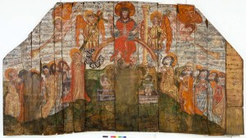
15th Century Doom Painting, Penn Parish Church. Photograph by V&A Images, but copyright Penn Parochial Church Council.
discovery of the famous medieval ‘Doom’ wall painting of the last judgement, hidden beneath the whitewash. This was only discovered when it was removed during refurbishment and left in the churchyard prior to destruction, when rain revealed the paint beneath. Another revelation was the wealth of information that Miles was able to garner from parish records and wills to the church and the way he was able to connect these to the religious and political currents of their time.
In all, a most rewarding visit for the many who attended the event.

